**ATS-USIT**

**VMS-TEST-Cases**

**Vendor:**

**Add Vendor:**

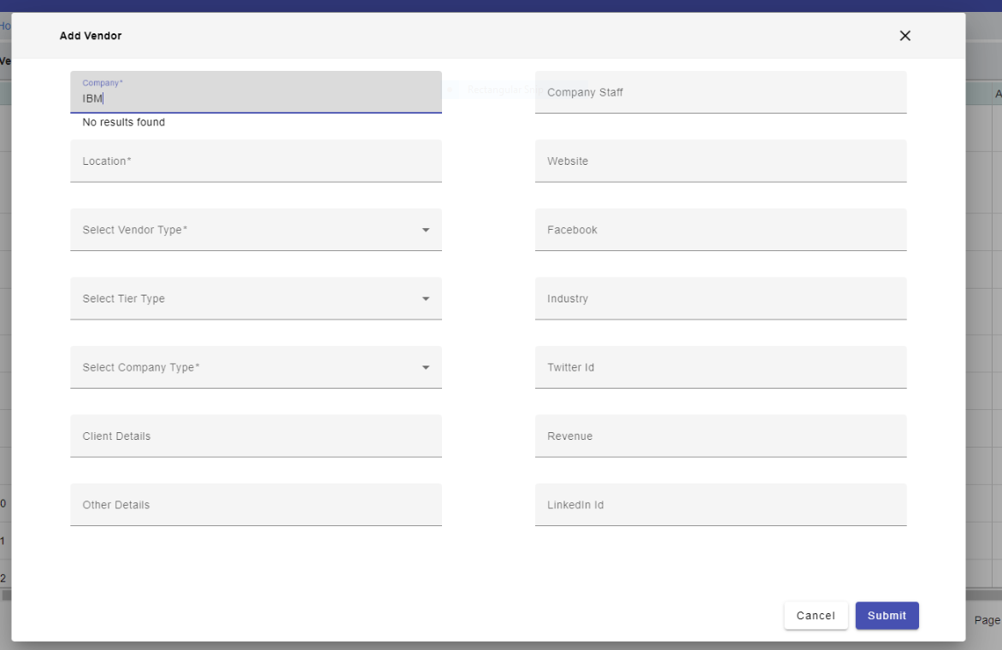

* Company: It's Not Showing Vendor Drop down

It has a length of 73 characters.

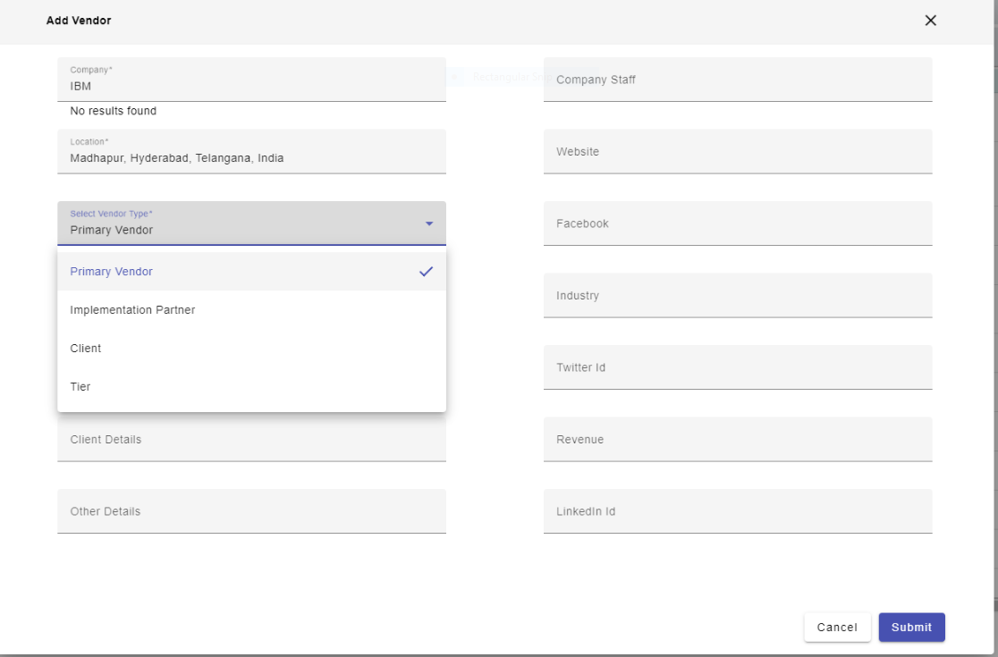

* Select Vendor Type: It would be better to reduce the size in between vendor type selections.

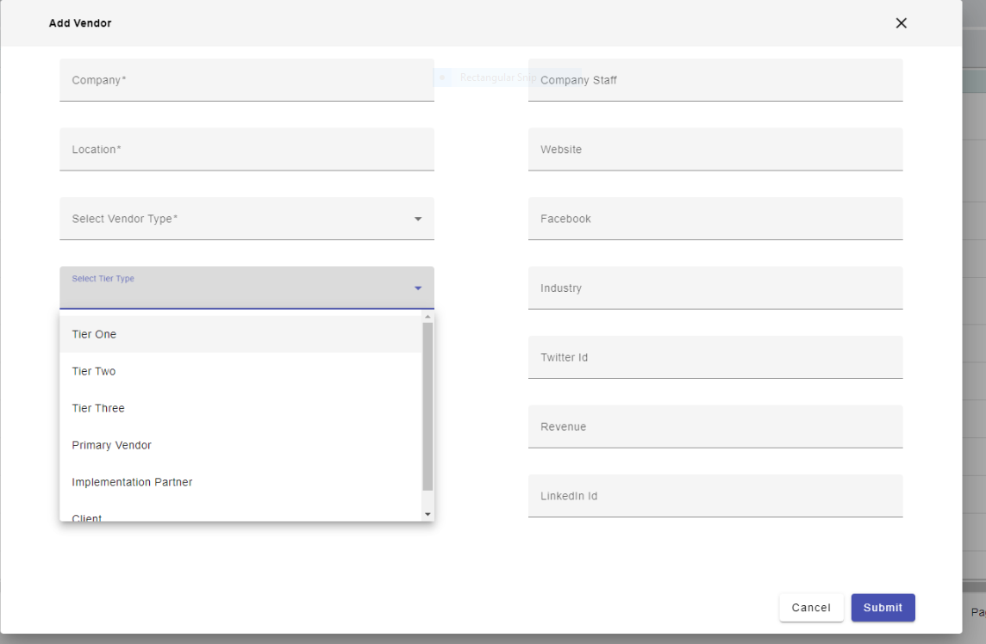

* Select Tier Type: It would be better to reduce the size in between vendor type selections.

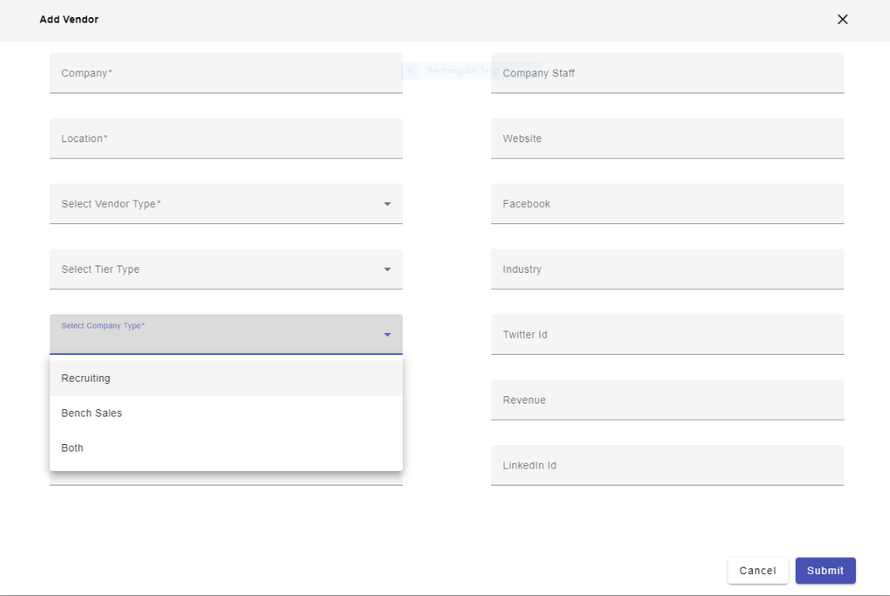

* Select Company Type: It would be better to reduce the size in between vendor type selections.
* Client Details: It Has a Length of 51 characters
* Other Details: it has a length of 183 characters
* Company Staff: It has a length of 7 characters
* Website: it has a length of 48 characters
* Facebook: It has a length of 104 characters
* Industry: It has a length of 26 characters
* Twitter Id: It has a length of 105 characters
* Revenue: It has a length of 20 characters
* LinkedIn Id: It has a length of 101 characters

***Recruiters:***

Add Recruiter:

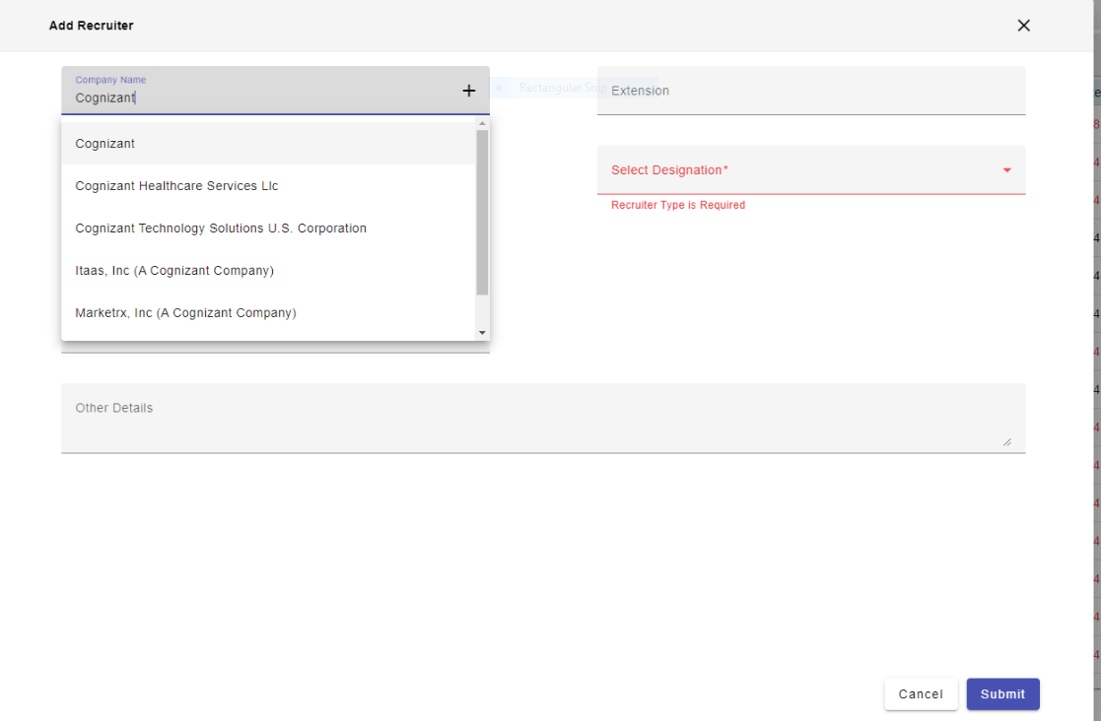

* Company Name: It would be better to reduce the size in between Company Name selections.
* Recruiter Name: It has a length of 50 characters
* Email: It's Taking duplicate email id

It has a length of 53 characters

* Company Contact Number : It's Taking Duplicate mobile number

It has a length of 10 digits

* Extention : it has a length of 4 digits

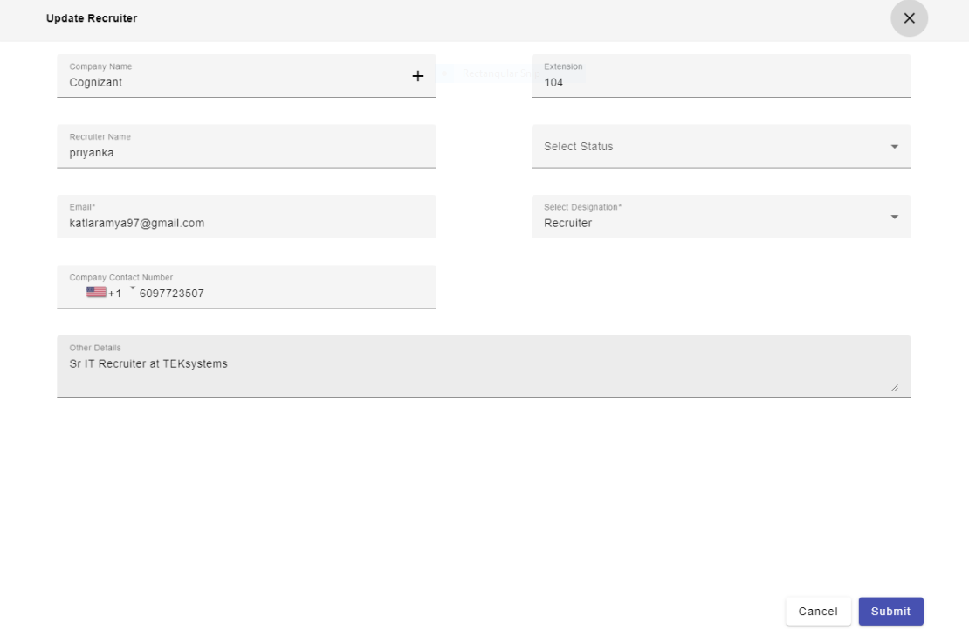

* Select Status: after updation approved status is not visible

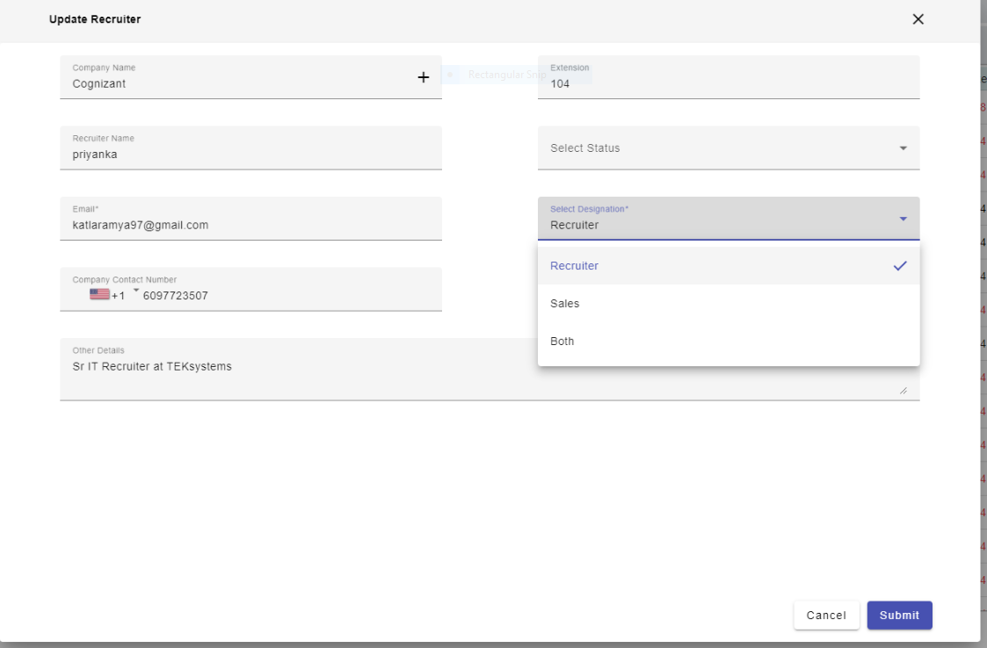

* Select Status: It would be better to reduce the size in between Company Name selections.

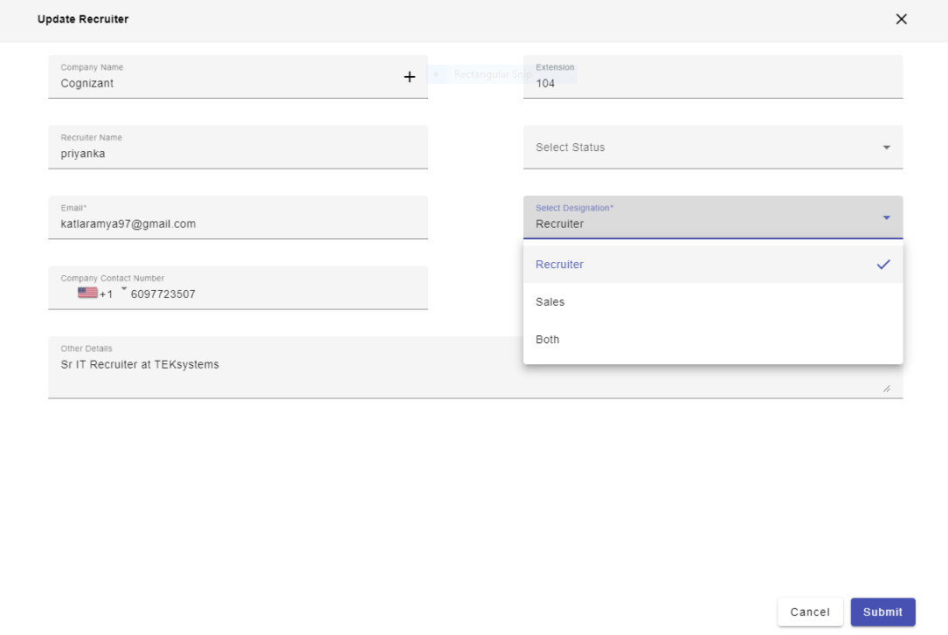

* Select Designation : It would be better to reduce the size in between designation selections.
* Other Details: it has a length of 244 characters