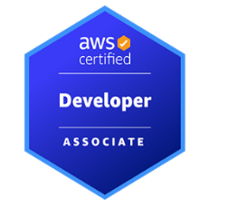
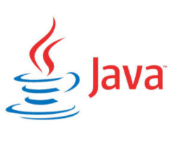
AVINASH M
Sr. Java Developer
mullapudiavinash06@gmail.com
Ph no: 862-256-2021
LinkedIn: linkedin.com/in/avinashm06

PROFESSIONAL SUMMARY:

10 years of professional experience in all the phases of software development life cycle like Design, Development, Integration of Client/Server environment, Documentation, Implementation and Testing and Strong in Data Structures and Algorithms.

- Expert in Various Software development methodologies like Waterfall model, Agile and its methodologies like Test Driven Development, Incremental, and Iteration methodology.
- Proficient in Java/J2EE/SpringBoot based web application design and development.
- Proficient in Elasticsearch, data modeling, and querying using log aggregation, data extraction, and reporting using Elasticsearch, Logstash, and Kibana tools.
- Expert in HTML5/CSS3 development and have experience in Backbone.js, Require.js, Node.js, Angular 8/9/10/11/12, Grunt JS, and Responsive design.
- Experience in Micro services development using spring boot and deployment in Pivotal Cloud Foundry (PCF).
- Experience in creating comprehensive web applications using MEAN stack implemented with MS SQL, Express, Angular JS 2/4/5 and Node.js, Java 8, 10, 11.
- Experience in Cloud Computing using PCF, Docker, AWS EC2, and S3.
- Designed and implemented error handling mechanisms and message retry strategies using IBM MQ dead-letter queues and message expiration policies, ensuring fault tolerance and message durability.
- Hands-on experience in the development of Microservices and deploying in Docker.
- Experience in developing scalable solutions using NoSQL databases CASSANDRA, and Mongo DB.
- Experience in creating Docker images, Containers, push/pull and integrating with Spring Boot.
- Experience in MVVM client-side JavaScript frameworks such as Angular6 and Angular8.
- Proficient with Typescript ES6 new features block scope, type restrictions, decorators, arrow functions, classes, interfaces, and modules (import and exports).
- Implemented Cloud Foundry for application deployment and management in a cloud environment.
- I have profound experience in Core Java 1.8 features like multi-Threading, concurrency, Stream and Filters API, Lambda functions and Functional interface programming.
- Expertise in implementation of J2EE Technologies: JSP, JTS, Servlets, JSF, JSTL, EJB transaction implementation, JMS, Struts2.0, Swing, Hibernate, Java Beans, JDBC, XML, Web Services, JNDI, Swing, Serialization and Externalization.
- Extensively worked on the Spring life cycle and its related modules like Spring Core, Spring IOC, Spring AOP, Spring MVC, Spring Transaction Management, Spring Batch, Spring Cloud, and Spring data.
- Experience in developing web applications on MVC-based frameworks like Spring, Spring IOC, Spring Security, Spring Boot, Spring Cloud, and Spring MVC.
- Developed the application using industry-standard design patterns like Singleton, Business Delegate, MVC and Factory Pattern, etc. for re-usability.
- Included Apache Kafka in Spring Boot application for API integration and Data Processing Pipeline for persistent messaging, working with Apache Kafka with Spring Integration which provides inbound adapters for working with low-level and high-level Apache Kafka API.
- Authenticated Users accessing RESTful services using OAuth 2.0, OIDC, and JWT (Jason Web token).
- Expertise knowledge in transactions frameworks like Spring AOP, JTA, and Spring Transaction Management.
- Experience in developing persistence layer using ORM frameworks like JPA, Hibernate, IBATIS, and Spring Data.
- Experience in deploying applications using Docker container services and building Continuous Integration (CI) and Deployment (CD) pipelines using Jenkins with GitHub.
TECHNICAL SKILLS:

Languages | Java, J2EE, C, C++, SQL, PL/SQL
Enterprise Java | Java, J2EE, Swing, RMI, Sockets, JDBC, Servlets, JSP, JMS, Java Beans, JSTL, JSF, Struts, EJB, Spring, JTA, JNDI and JPA
Web/XML Technologies | HTML5, CSS3, JavaScript, jQuery, ReactJS, AngularJS, Angular2/6, BackboneJS, ReactJS, XML, XSD, XSL/XSLT, SAX/DOM, AJAX, JSON, DOJO and NodeJS.
Tools & Framework | Struts, Hibernate, Spring MVC, Spring Web Flow, Spring IOC, Spring AOP, JMS, JSF, Log4J, SOA, Jasper reports, Spring Boot, Spring Batch, Spring Security, Spring Data, Jersey.
Web services | SOAP, RESTful, UDDI, WSDL, JAX-RPC, JAX-RS, JAX-WS, JAX-B, Micro services, Apache Axis and Apache CFX.
Web/App Servers | Web Sphere, WebLogic, Apache, Tomcat and JBoss.
Database | OracleDB, SQL-Server, MySQL server, MS SQL, PL/SQL, MongoDB and NoSQL
Development Tools | Eclipse, RAD, Spring Tool Suite (STS) and IntelliJ
O-R mapping | Hibernate, JPA and JTA
Testing Tools/ Others | JUnit, Jasmine, SoapUI, Postman, Putty, Rational Clear Quest, RTC, Load UI and JIRA
Version Control | GIT, CVS, SVN, Rational clear case and Star Team
Platforms | Windows, Win 2k Server, Sun Solaris and UNIX
Cloud Technologies | AWS (Amazon Web Services)

EDUCATIONAL BACKGROUND:
Bachelor of Science in Computer Science-2014

Professional Experience:


TRUIST BANK, NJ
Role: Sr. Java Developer
Feb 2023 – Till Date

Description:
TRUIST Bank is a prominent North American financial institution. As a Java Developer with TRUIST Bank, I have played a key role in designing and implementing digital banking solutions, enhancing online customer portals, and streamlining backend systems to ensure swift and secure financial transactions.

Responsibilities:
- Involved in the analysis, design, and development phases of the Software Development Life Cycle (SDLC) using Agile (SCRUM) development methodology and Test-Driven Development process to deliver regular updates to business team and project managers.
- Developed UI pages using HTML5, TypeScript, Angular 8, Bootstrap, CSS3, jQuery, AJAX and NodeJS.
- Build the reusable service components with Angular 8, Bootstrap and JSX to use across modules.
- Implemented jQuery to develop the widgets and to perform the client-side validations.
- Used Core Java and advanced java 8 features like Lambda expressions for array operations, Streams, Method reference, Collections, Multi-Threading etc. Enhanced concurrency methods etc.
- Used Annotations for Dependency Injection and Spring Boot for Micro services. Implemented functionalities using Spring IO / Spring Boot with Hibernate ORM
- Used Spring Framework AOP Module to implement logging in the application to know the application status.
- Developed Application to access JSON and XML from Restful web service.
- Used Micro Services architecture with Spring Boot services interacting through REST.
- Deployed Spring Boot based Micro Services into Docker containers using Amazon EC2 container services and implemented Spring REST to create REST endpoints and integrated Swagger to get dynamic documentation.
- Implemented Cloud Foundry for application deployment and management in a cloud environment.
- Worked on partition of Kafka messages and setting up the replication factors in Kafka Cluster.
- Used HQL, Named Parameters, Queries, and Interfaces such as Expression, Query and Criteria for implementation of Hibernate template and used Hibernate Cache.
- Experience in working with Amazon Web Services(AWS) like EC2, S3, Amazon simple DB, Amazon RDS, Amazon Elastic Load Balancing, AWS identity, Amazon SQS and access management, AWS cloud watch, AWS EBS.
- Used AWS Cloud watch in alerting, maintaining, and monitoring of production and servers.
- Experience with building Docker Images and running them on Docker container.
- Configured and administered Jenkins for CI/CD into Tomcat Application Server.
- Used JIRA to assign, track, report and audit the issues in the application by sprint process.
- Used IntelliJ for development and debugging the application and Used GIT for version control.
- Developed Mongo DB Data Access Layer implementing Mongo Repository interface from Spring Data.
- Report generation in MongoDB using JavaScript, shell scripting, java
- Wrote SQL Queries, Stored Procedures, Triggers, Views, and enhanced performance with explain plans.

Environment:
Core Java, Java 8/J2EE, Angular 8, TypeScript, Spring Boot, Spring Security, Eureka, Hibernate 4.x, Microservices, REST, Docker, AWS IAM, JIRA, Git, Maven, Jenkins, Mockito, MongoDB,Oracle.

COMMONWEALTH BANK
Role: Java Developer
June 2019 – Nov 2022

Description:
Commonwealth Bank of Australia provides banking, life insurance, and related services for individuals, small businesses, and medium sized commercial enterprises. As a developer I have worked on different APIs like profile management service, statement service and payment processing APIs like VISA and master cards.

Responsibilities:
- Created multiple REST endpoints performing different functionalities including JSON input and Multipart file input.
- Designing and developing Restful APIs using best practices to interact within the microservices and with the front end.
- Created CI/CD pipelines and created Jenkins to deploy builds to AWS.
- Developed POJOs for Data Model and made individual HBM records to delineate Java Objects with Relational database tables.
- Conducted unit testing using the open-source Karma and Jasmine tools and used Protractor for end-to-end testing.
- Responsible for creating graphical data representations using React JS.
- Developed RESTful web service using the Spring Reactive Handler, Router and Web Client components to perform the business needs.
- Developed code for automated email using Python and sending reports to internal members by using automated email.
- Developed and executed integration tests using frameworks such as JUnit to validate the correctness of
- MongoDB interactions within the Java application.
- Developed CI/CD system with Jenkins on Kubernetes environment, utilized Kubernetes and Docker for the runtime environment for the CI/CD system to build, Test, and Deploy.
- Worked on Kafka integration with Spark using Spark Streaming API.
- Used Node.js for server-side rendering and integration with designs and requirements.
- Implemented functionalities using Spring Boot and Hibernate ORM.
- Used ReactJS to capture user actions and render the relevant action, as well as dynamically render the UI based on user actions.
- Utilized Web Sockets with React to maintain consistent and real-time state across users.
- Used Spring framework for the MVC implementation with spring for DI, Hibernate as ORM tool, and Simple JDBC calls for database communication.
- Utilized Jenkins for continuous integration and deployment into the WebLogic application server.
- Designed and developed asynchronous RESTful Microservices using Spring boot that is consumed by other microservices.

Environment:
Agile (SCRUM), Java 8, HTML5, CSS3, JavaScript, jQuery, Ajax, Bootstrap, ReactJs, AWS (Amazon web services), Micro-Services, Spring, Kafka, Spring Batch, Spring Boot, Spring Security, Servlet, XML, GIT, Spring MVC, JDBC, JUnit, Maven, Restful, Log4J, Java Server Pages, JIRA, Jenkins, and STS.


HCL TECHNOLOGIES
Role: Java Back End developer
April 2016- July 2019

Responsibilities:
- Followed Agile (Scrum) development methodology and participated in daily Stand-up meetings to update the task status on the assigned tasks such as technical documentation, development of different modules.
- Involved in design and implementation of Microservices using Spring Boot and CI/CD tools on Kubernetes.
- Developed and maintained troubleshooting flows on top of microservices using BPMN tools such as Bonita and Red Hat PAM.
- Worked Extensively on Spring Boot to build several services as external microservices and configure them to communicate with each other or with another part of the system.
- Used Amazon Cloud Watch to monitor AWS services and Amazon Cloud Watch logs to monitor application.
- Build and maintain code repositories and code migrations using CI/CD strategies (GIT, SVN, CSV, Jenkins).
- Used Hibernate framework for object relational mapping and persistence.
- Involved in writing SQL queries, stored procedures, and triggers in databases via Oracle and DB2.
- Involved in developing and modifying UNIX shell scripts for batch jobs.
- Used Microservice architecture with SpringBoot based services interacting through a combination of REST and Apache Kafka message brokers and worked with Kafka Cluster using Zookeeper.
- Implemented user-friendly web-based applications using AngularJS, HTML5, CSS3, Bootstrap, Spring and MongoDB.
- Use of data structures and algorithms for time and memory complexity reduction
- Implemented JWT mechanism for authentication, authorization, and data exchange.
- Used Spring Core for IOC implemented using DI and developing Restful web services.
- Integration of Amazon Web Services (AWS) with other applications infrastructure.
- Extensively worked with CI/CD tools like Jenkins for deploying Microservices on Kubernetes cluster and used Rancher for Kubernetes to monitor the deployed applications.
- Implemented Microservices using Spring Core, Spring Boot, Spring Data, Spring Rest and Spring Cloud (PCF).
- Worked on developing applications, automated scripts leveraging MongoDB.
- Selecting the appropriate AWS service based on computer, data, or security requirements.
- Worked with Behavior Driven Development process and Test-Driven Development (TDD).
- Used GIT as a version control system and Bit Bucket as the source code repository.

Environment:
Java 7, Design Patterns, Microservices, Bonita, RedHat PAM, Spring Boot, Spring JDBC, Hibernate, REST, XML, Eclipse, JBoss, Kafka, UNIX, LINUX, Spring Core, Oracle, SQL, Putty, SQL Server, Swagger, Postman, GIT, CI/CD, AWS, Jenkins, Kubernetes, Junit, Mockito, TDD, Agile, JIRA, Tomcat.
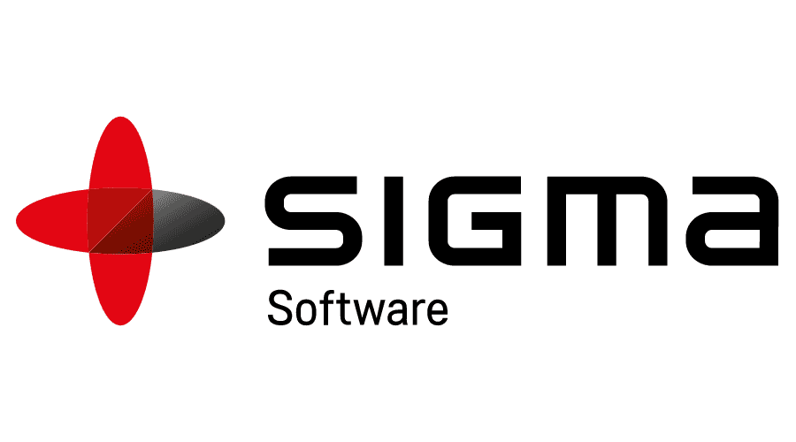
SIGMA SOFTWARE SOLUTIONS
Role: Java Developer
March 2014 – April 2016

Responsibilities:
- Developed web application using Struts 2.X, JSP, Servlet, Java beans that uses MVC design pattern.
- Created user-friendly GUI interface and Web pages using HTML, CSS and JSP.
- Wrote JavaScript and jQuery for client-side validation.
- Used Eclipse as IDE tool for creating Servlet, JSP, and XML.
- Wrote SQL for JDBC prepared statements to retrieve the data from database.
- Monitored the logs using Log4J and fixed the problem.
- The application was deployed on Tomcat.
- Involved in building and deploying the application using Ant.
- Used CVS as version control system.
- Worked on production bugs with highest priority and worked with the backend team to design API’s.
- Implemented test cases and performed end to end unit testing and writing the rules.
- Gained exposure on the backend by learning and implementing java in the form of bug fixes.
- Worked on bug fixing and Production Support.
- Involved in UAT support/ Unit Testing and participated in Build activities.
- Implementing Log4J for logging messages with various levels written throughout the Java code.

Environment:
J2EE, JDBC, Struts, JavaScript, Html, CSS, JSP, Servlet, Tomcat, Oracle, Eclipse IDE, CVS, ANT, Log4J.

