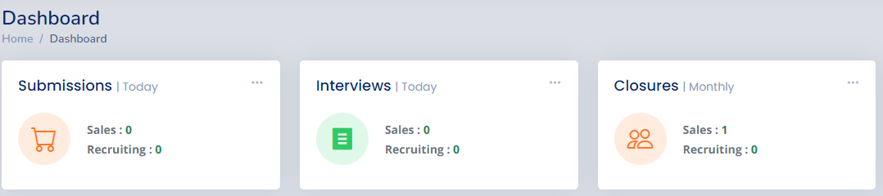

Fig 1.1

* Out of all available 3 grids, in first one we will maintain the stats related to the submissions i.e., daily/weekly/monthly submissions submitted in the portal
* In the second grid we provide the data related to the no. of interviews that are scheduled in this day/week/month
* In the final grid we are gona maintain the stats that are related to the closers which means no. of Closers that are done in the current month/Quarter-1/ Quarter-2/ Quarter-3/ Quarter-4/current annual year

SUBMISSIONS:

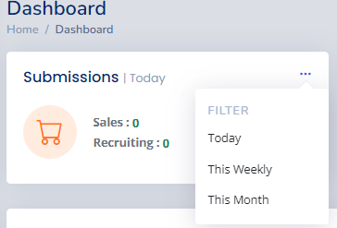

Fig 1.2

Daily Records count:

* Need to get the today (current day) submissions count in both sales and recruitment

Ex: If bench sales executive logged in today dated on ‘2023-09-26’ in 9 am and done 2 submissions with in 10 am then need to display submission count in sales as 2 up to 10am, then after bench sales team lead logged in on 10 am up to 1pm he/she submitted 3 submissions and up to same time already logged in sales executive done 2 more submissions so up to 1pm need to show the 7 submissions in sales as total today’s count

* Similarly, if recruiter from recruiting team logged in today dated on ‘2023-09-26’ in 9 am and done 3 submissions within 10 am then need to display submission count in recruiting as 3 up to 10am, then after recruiting team lead logged in on 10 am up to 1pm he/she submitted 2 submissions and up to same time already logged in recruiter done 2 more submissions so up to 1pm need to show the 7 submissions in recruiting as total today’s count

Weekly Records count:

* Also need to get the weekly submitted records count
* Here the week means Monday to Saturday of this week in this month of this year
* Ex: If Monday came on the date: ‘2023-09-25’ then Saturday on date: ‘2023-09-30’ then need to fetch the count of both sales and recruitment in between the dates

Means, if the current date is Thursday dated on ‘2023-09-28’ need to get the submissions count from Monday dated on ‘2023-09-25’ to Thursday dated on ‘2023-09-28’ as total weekly submissions count in sales as well as recruiting

If current date is Tuesday dated on ‘2023-09-26’, then need to get the submission count in both sales and recruiting from Monday i.e. ‘2023-09-25’ to Tuesday dated ‘2023-09-26’’

Monthly Records count:

* Part of monthly records count fetch, we need to consider from last month 20 to current month 21 as a month
* If current date is ‘2023-09-20’ then we need to get monthly count in between the ‘2023-08-20’ to ‘2023-09-21’
* If current date is ‘2023-09-26’ then we need to get monthly count in between the ‘2023-09-21’ to ‘2023-10-21’
* Means, 01 to 21 of current month then need to fetch the submission of from last month 20 to current month 21
* Current date is from 21 to 31 of current month, then need to need fetch the count of between current month 21 to next month 20

Quarter-1 Records count:

* Here in quarter-1, Jan to Mar will come as first quarter
* Which means need to fetch the records counts in between jan-01 to mar-31 as quarter-1 submissions count
* If the submitted record is created in just April-01, then it will fall under quarter-2 count not as a first quarter
* If the submitted record is created in just Dec-31, then it will fall under quarter-4 count not as a first quarter

Quarter-2 Records count:

* Here in quarter-2, Apr to Jun will come as second quarter
* Which means need to fetch the records counts in between Apr-01 to Jun-30 as quarter-2 submissions count
* If the submitted record is created in just July-01, then it will fall under quarter-3 count not as a second quarter
* If the submitted record is created in Mar-31, then it will fall under quarter-1 count not as a second quarter

Quarter-3 Records count:

* Here in quarter-3, Jul to Sept will come as third quarter
* Which means need to fetch the records counts in between Jul-01 to Sept-30 as quarter-3 submissions count
* If the submitted record is created in just Oct-01, then it will fall under quarter-4 count not as a second quarter
* If the submitted record is created in Jun-30, then it will fall under quarter-2 count not as a second quarter

Quarter-4 Records count:

* Here in quarter-4, Oct to Dec will come as fourth quarter
* Which means need to fetch the records counts in between Oct-01 to Dec-31 as quarter-4 submissions count
* If the submitted record is created in just Jan-01, then it will fall under quarter-1 count not as a fourth quarter
* If the submitted record is created in Sep-30, then it will fall under quarter-3 count not as a second quarter

Yearly Records count:

* Here in yearly, Jan-01 to Dec-31 will come as one annual
* Which means need to fetch the records counts in between Jan-01 to Dec-31 as annual submissions count in both sales and recruiting
* If the submitted record is created in just 2024-jan-01, then it will fall under other year, so it will not be in current year count

INTERVIEWS:

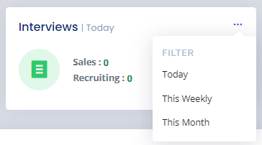

Fig 1.3

Daily Records count:

* Need to get the today (current day) interviews count in both sales and recruitment

Ex: If bench sales executive logged in today dated on ‘2023-09-26’ in 9 am and scheduled 2 interviews within 10 am then need to display interviews count in sales as 2 up to 10am, then after bench sales team lead logged in on 10 am up to 1pm he/she submitted 3 submissions and up to same time already logged in sales executive done 2 more submissions so up to 1pm need to show the 7 submissions in sales as total today’s count

* Similarly, if recruiter from recruiting team logged in today dated on ‘2023-09-26’ in 9 am and done 3 submissions within 10 am then need to display submission count in recruiting as 3 up to 10am, then after recruiting team lead logged in on 10 am up to 1pm he/she submitted 2 submissions and up to same time already logged in recruiter done 2 more submissions so up to 1pm need to show the 7 submissions in recruiting as total today’s count

Weekly Records count:

* Also need to get the weekly submitted records count
* Here the week means Monday to Saturday of this week in this month of this year
* Ex: If Monday came on the date: ‘2023-09-25’ then Saturday on date: ‘2023-09-30’ then need to fetch the count of both sales and recruitment in between the dates

Means, if the current date is Thursday dated on ‘2023-09-28’ need to get the submissions count from Monday dated on ‘2023-09-25’ to Thursday dated on ‘2023-09-28’ as total weekly submissions count in sales as well as recruiting

If current date is Tuesday dated on ‘2023-09-26’, then need to get the submission count in both sales and recruiting from Monday i.e. ‘2023-09-25’ to Tuesday dated ‘2023-09-26’’

Monthly Records count:

* Part of monthly records count fetch, we need to consider from last month 20 to current month 21 as a month
* If current date is ‘2023-09-20’ then we need to get monthly count in between the ‘2023-08-20’ to ‘2023-09-21’
* If current date is ‘2023-09-26’ then we need to get monthly count in between the ‘2023-09-21’ to ‘2023-10-21’
* Means, 01 to 21 of current month then need to fetch the submission of from last month 20 to current month 21
* Current date is from 21 to 31 of current month, then need to need fetch the count of between current month 21 to next month 20

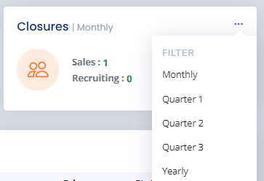

Fig 1.4

Monthly Records count:

* Part of monthly records count fetch, we need to consider from last month 20 to current month 21 as a month
* If current date is ‘2023-09-20’ then we need to get monthly count in between the ‘2023-08-20’ to ‘2023-09-21’
* If current date is ‘2023-09-26’ then we need to get monthly count in between the ‘2023-09-21’ to ‘2023-10-21’
* Means, 01 to 21 of current month then need to fetch the submission of from last month 20 to current month 21
* Current date is from 21 to 31 of current month, then need to need fetch the count of between current month 21 to next month 20

Quarter-1 Records count:

* Here in quarter-1, Jan to Mar will come as first quarter
* Which means need to fetch the records counts in between jan-01 to mar-31 as quarter-1 submissions count
* If the submitted record is created in just April-01, then it will fall under quarter-2 count not as a first quarter
* If the submitted record is created in just Dec-31, then it will fall under quarter-4 count not as a first quarter

Quarter-2 Records count:

* Here in quarter-2, Apr to Jun will come as second quarter
* Which means need to fetch the records counts in between Apr-01 to Jun-30 as quarter-2 submissions count
* If the submitted record is created in just July-01, then it will fall under quarter-3 count not as a second quarter
* If the submitted record is created in Mar-31, then it will fall under quarter-1 count not as a second quarter

Quarter-3 Records count:

* Here in quarter-3, Jul to Sept will come as third quarter
* Which means need to fetch the records counts in between Jul-01 to Sept-30 as quarter-3 submissions count
* If the submitted record is created in just Oct-01, then it will fall under quarter-4 count not as a second quarter
* If the submitted record is created in Jun-30, then it will fall under quarter-2 count not as a second quarter

Quarter-4 Records count:

* Here in quarter-4, Oct to Dec will come as fourth quarter
* Which means need to fetch the records counts in between Oct-01 to Dec-31 as quarter-4 submissions count
* If the submitted record is created in just Jan-01, then it will fall under quarter-1 count not as a fourth quarter
* If the submitted record is created in Sep-30, then it will fall under quarter-3 count not as a second quarter

Yearly Records count:

* Here in yearly, Jan-01 to Dec-31 will come as one annual
* Which means need to fetch the records counts in between Jan-01 to Dec-31 as annual submissions count in both sales and recruiting
* If the submitted record is created in just 2024-jan-01, then it will fall under other year, so it will not be in current year count