Rajesh Karampudi

Sr. Python AWS Developer

**Email;Rajeshk.kavi@gmail.com Contact: +1609-830-4082**

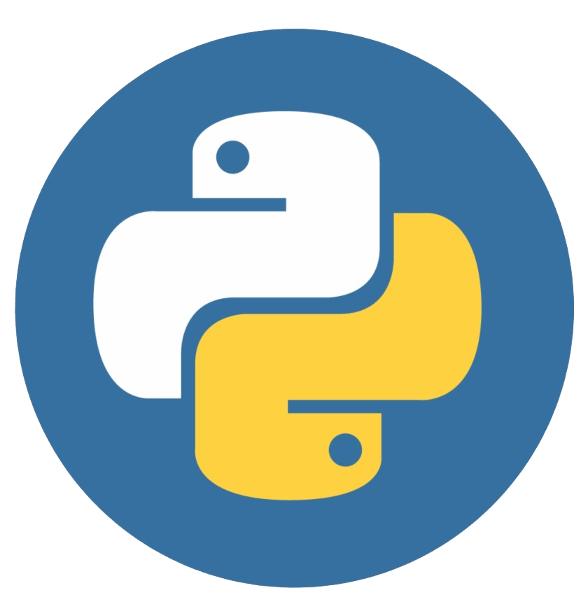

**Professional Summary:**

* 10+ years of experience in Design, Development, Management, and Implementation of various stand-alone, client-server enterprise applications using Python scripting, Django.
* Good knowledge in maintaining various version controls systems such as SVN (Centralized Version Control System) and GIT (Distributed Version Control System).
* Hands-on experience in WAMP (Windows, Apache, MYSQL, Python) and LAMP (Linux, Apache, MySQL, and Python) Architecture.
* Expertise in AWS Cloud platform and its features which includes EC2, AMI, EBS Cloud watch, AWS Config, Auto-scaling, IAM user management and AWS S3.
* Good experience in developing web applications implementing Model View Control architecture using Django and Flask web application frameworks.
* Good knowledge in GUI frameworks - Python, Pyjamas.
* Knowledge of the Software Development Life Cycle (SDLC), Agile and Waterfall Methodologies and active participation in full development life cycle (includes requirements, design, architecture, development, Implementation, and testing).
* Hands-on experience in AWS Cloud with proficiency in services such as Lambda, SQS, API Gateway, RDS, and CloudWatch.
* Skilled in deploying and managing applications in an automated and scalable manner using AWS Elastic Beanstalk.
* Familiarity with AWS Identity and Access Management (IAM) for managing user access and permissions in the cloud environment.
* Experienced in NoSQL technologies like MongoDB, Cassandra, Redis and relational databases like Oracle, SQL Lite, PostgreSQL and MySQL databases.
* Experienced in Working on Big Data Integration and Analytics based on Hadoop and Kafka.
* Good knowledge of using IDE Tools like IDLE, Eclipse, NetBeans, PyCharm, and Sublime Text.
* Experienced in using Python libraries like Beautiful Soup, NumPy, SciPy, matplotlib, Python-twitter, urllib2, and MySQL for database connectivity.
* Experience in UNIX and Linux shell environments using command line utilities.
* Experience with Unit Testing/ Test Driven Development (TDD), Load Testing and Integration Testing.
* Good experience on MongoDB scaling across data centers and/or in-depth understanding of MongoDB HA strategies, including replica sets.
* Experience in writing Sub Queries, Stored Procedures, Triggers, Cursors, and Functions on MySQL and PostgreSQL database.
* Comfortable working with MEAN (MongoDB, Express).
* Familiar with tools including Bugzilla, Jira, and Confluence.
* Implemented machine learning algorithms in Spark and Python, for segmentation of data.
* Experience in implementation of MVC/ MVW architecture using Django, and RESTful, SOAP web service and SOAPUI.
* Well versed with design and development of presentation layer for web applications using technologies like HTML5, CSS3, Bootstrap, XML, Backbone JSON.
* Strong knowledge of secure coding principles, including input validation, output encoding, secure session management, and secure error handling.
* Proficiency in Agile Methodologies, Scrum stories and sprints experience in a Python-based environment, along with data analytics, data wrangling, and Excel data extracts.

**Education Details:**

* **Masters in Cyber Security**, Iowa State University, Ames, IA
* **Bachelors in Computer Science**, Vignan Institute of Technology and Science, India

**Technical Skills:**

|  |  |
| --- | --- |
| **Programming Languages:** | Python 3.x,2.7/2.4, Java, C, R, C++, Golang, Shell programming, PL/SQL. |
| **Web Technologies:** | HTML, XHTML, CSS, JavaScript, NodeJS, jQuery, AJAX, AngularJS, Angular, React JS, XML. |
| **Frameworks:** | Django, Flask, Pyramid, Web2py, Bootstrap |
| **Python Libraries** | NumPy, SciPy, Scikit, Pandas, Jupiter, Matplotlib, Urllib2, Python-twitter |
| **Databases:** | MySQL, Oracle, PostgreSQL, DB2, SQL Server 2008, Oracle 10g, Siebel, NoSQL - MongoDB and Cassandra |
| **Web Services:** | AWS - EMR, EC2, S3, RDS, Azure Databricks, Azure Data Factory, GCP |
| **Scripting Languages:** | CSS, AJAX, JavaScript, jQuery, PHP, PowerShell Scripting |
| **Version Control:** | GitLab, GitHub, SVN, CVS |
| **Deployment Tools:** | Heroku, Jenkins, Ansible |
| **Operating Systems:** | UNIX, Linux, Windows, Mac OS |
| **Testing Tools:** | Selenium, HP QC, HP QTP |
| **Methodologies:** | Agile, Scrum, Waterfall, and Iterative |

**Professional Experience:**

**Client: E*TRADE, Dallas, TX Nov 2021 – Till Date**

**Role: Sr. Python / AWS Developer**

**Responsibilities:**

* Involved in the development of the applications using Python, HTML5, CSS3, AJAX, JSON, and jQuery.
* Imported the data from different sources like cloud services, Local file system into Spark RDD and worked on cloud Amazon Web Services (EMR, S3, EC2, Lambda).
* Developed custom logic using AWS platform like AWS Lambda(s), AWS step function(s), AWS S3 buckets to perform banking calculations and deployed in CI/CD pipelines using Jenkins.
* Verified and validated the code using pytest and maintained test coverage at 80%.
* Involved in building database Model, APIs and Views utilizing Python, in order to build an interactive web-based solution.
* Implemented PySpark using Python and utilizing data frames and temporary table SQL for faster processing of data.
* Use of AWS including deploying new server instances through automation with Kubernetes and Jenkins.
* Worked on PyUnit, the Python unit test framework, for the python applications.
* Involved in business logic discussions and use case design.
* Created Data tables utilizing MySQL utilized Jinja to access data and display it in the front end.
* Made Django web-based apps for Insurance premium calculations.
* Developed a fully automated continuous integration system using Git, Jenkins, MySQL and custom tools developed in Python and Bash.
* Developed three early prototypes using GraphQL, Apollo, and AWS services Cognito, Appsync and DynamoDB.
* Worked on Python (NumPy, spicy, pandas, scikit-learn, seaborn) to develop variety of models and algorithms for analytic purposes.
* Designed the database structure for the application in DynamoDB, a NoSQL Db from AWS.
* Worked on Creating RESTful web services with Django MVT, MySQL, and MongoDB.
* Created test harness to enable comprehensive testing utilizing Python.
* Designed and managed API system deployment using fast http server.
* Used GitHub for version control.
* Designed and developed components using Python with Django framework.
* Worked on controllers, views and models in Django.
* Created and executed test plans using PyUnit, Apache CGI, Cherrypy, Python and Bash programming on Red Hat virtual machines to maintain and automate Splunk server deployments and other in-house IT operations.
* Used JQuery and Ajax calls for transmitting JSON data objects between frontend and controllers.
* Worked in an agile development environment.

**Environment:** Python 3.7, AWS, EC2, EBS, S3, VPC, PyCharm, PyUnit, Django, JQuery, MySQL, HTML5, CSS3, JavaScript, Ajax, Web Services, JSON, Bootstrap, Jinja, Flask, SQL, Bash, GitHub, MongoDB, Windows.

**Client: Core First Bank & Trust, Topeka, KS Dec 2019 – Oct 2021**

**Role: Sr. Python / AWS Developer**

**Responsibilities:**

* Analyzed and gathered business requirements specifications by interacting with client and understanding business requirement specification documents.
* Developed the presentation layer using HTML, CSS, JavaScript, JQuery and AJAX.
* Used JQuery libraries for all client-side JavaScript manipulations.
* Utilized Python libraries WxPython, NumPy, Twisted and matPlotLib.
* Implemented SQL Alchemy which is a python library for complete access over SQL.
* Worked on Element Tree XML API in python to parse XML documents and load the data in database.
* Skilled in collections and used for manipulating and looping through different user defined objects.
* Developed views and templates with Python and Django's view controller and templating language to created user-friendly website interface.
* Developed REST Microservices which are like API’s used for Home Automation. They also keep the data in synchronization between two database services.
* Configuring auto scalable and highly available microservices set with monitoring and logging using AWS, Docker, Jenkins and Splunk
* Designing, implementing, and maintaining solutions for using Docker, Jenkins, Git, and Puppet for microservices and continuous deployment.
* Used Django configuration to manage URLs and application parameters.
* Created entire application using Python, Django, MySQL and Linux.
* Used Amazon Elastic Beanstalk with Amazon EC2 to deploy project into AWS.
* Accessed database objects using Django Database APIs.
* Created database using MySQL, wrote several queries to extract/store data.
* Exported/Imported data between various data sources.
* Integrated data from multiple applications using ETL and ELT tools like SSIS.
* Experienced in Agile Methodologies and SCRUM Process.
* Identified several hidden bugs caused by complicated multithreading issues such as race conditions caused by asynchronous events and resolved them.
* Responsible for debugging and troubleshooting the web application.
* Took part in the entire project's lifecycle which includes Design, Development and Deploying, Testing, Implementation, and support.
* Used Design patterns efficiently to improve the code reusability.
* Coordinated with the offshore development team and assisted them when required.

**Environment:** Python, AWS, EC2, EBS, S3, VPC, PyCharm, jQuery, MySQL, HTML, CSS, JavaScript, Ajax, Web Services, JSON, MongoDB, SQL Workbench.

**Client: MTNL, India Nov 2016 – Nov 2018**

**Role: Python Developer**

**Responsibilities:**

* Developed entire frontend and backend modules using Python on Django Web Framework.
* Written APIs for various items in each Sprint and the Backlog.
* Designing and implementing the architecture of the application
* Extensively worked on Python scripting and development. CSS is used to style Web pages and XHTML markup.
* Build SQL queries for performing various CRUD operations.
* Implemented Servlets to handle HTTP requests for online requests, credit card payments, registration, and bug tracking. Used Bootstrap for responsive design.
* Worked on the development of SQL and Stored Procedures on MYSQL
* Built the web application by using Python, J2EE, PostgreSQL, MySQL, Oracle 10g.
* Collaborating with other teams, such as product and design, to understand and implement requirements.
* Utilized AWS services like Lambda, SQS, API Gateway, RDS, CloudWatch, and Data Lake Concepts to enhance application functionality, scalability, and monitoring capabilities.
* Ensured the application adheres to best practices and industry standards.
* Designed, rated and implemented BI solutions.
* Integrated the application with AWS RDS for reliable and scalable database storage.
* Evaluated, repaired and improved current BI systems.
* Translated business goals into technical specifications.
* Created interactive visual reports using BI tools.
* Collaborated with teams and managers to help businesses develop.
* Found correlations in data to discover meaningful insights.
* Identifying key performance indicators (KPI) to help companies adjust and fulfill objectives.
* Wrote a customized Python profiler for performance testing, analysis, and predictions.
* Published documentation for Confluence and SharePoint to support the APIs I wrote.
* Assisted with the development of the CI/CD pipeline, wrote automated tests, and advised on the groovy script.
* Utilized AWS SDKs and CLI to interact with various AWS services and automate operational tasks.
* Did unit test and regression test framework for working code.
* Using the Subversion version control tool to coordinate team development.
* Responsible for debugging and troubleshooting the web application, handled all the client-side validation using JavaScript, and Designed and developed a data management system using MySQL.

**Environment:** Python, AWS, Java, RESTful API, PostgreSQL, JavaScript, MySQL, GitHub, JIRA, Confluence, SharePoint, Jenkins, PyCharm, UNIX, NodeJS, and Windows.

**Client: Polaris, India Jul 2014 – Oct 2016**

**Role: Python Developer**

**Responsibilities:**

* Designed and developed the user interface of the project with HTML, CSS and JavaScript
* Entire Front end and back-end modules of the project are developed using Python with Django Framework.
* Developed a fully automated continuous integration system using Git, Gerrit, Jenkins, MySQL, and custom tools developed in Python and Bash.
* Designed and developed the data management systems using MySQL databases.
* Written Python Scripts to parse the XML documents and load the data in database.
* Utilized the existing Python and Django modules and rewritten to deliver data in required formats.
* Used HTML/CSS and JavaScript for UI development.
* Utilized Python in the handling of all hits on Django, Redis, and other applications.
* Client-side validations and manipulations are done using JavaScript and jQuery.
* Experienced in writing indexes, views, constraints, stored procedures, triggers, cursors and user defined.
* Deployed continuous delivery with Docker, Jenkins, and GitHub.
* Development of Python APIs to dump the array structures in the Processor at the failure point for debugging.
* Responsible for Debugging and troubleshooting the application.
* Utilized Subversion control tool to coordinate team work.
* Used Python and Django to interface with the JQuery UI and manage the storage and deletion of content.

**Environment:** Python 2.6, Django, UNIX, HTML, XML, CSS, JavaScript, MySQL and Bugzilla.

**Client: Aspect Software, India Aug 2012 – Jun 2014**

**Role: Python Developer**

**Responsibilities:**

* Worked on requirement gathering and High-level design.
* Used Python scripts to update content in the database and manipulate files.
* Converted Visual Basic Application to Python and MSQL.
* Used HTML/CSS and JavaScript for UI development.
* Experience in using Ubuntu OS
* Developed object-oriented programming to enhance company product management.
* Utilized Python in the handling of all hits on Django, Redis, and other applications.
* Used several Python libraries like python, NumPy and matplotlib.
* Was involved in environment code installation as well as the SVN implementation.
* Created unit test/regression test framework for working/new code.
* Responsible for debugging and troubleshooting the web application.
* Build all database mapping classes using Django models.

**Environment:** Python, SVN, Eclipse, Java Script, XML, Linux, Bugzilla, HTML5/CSS.