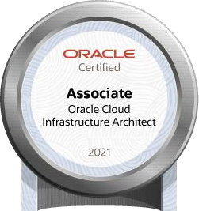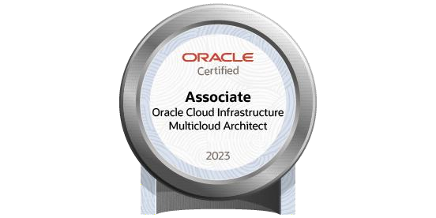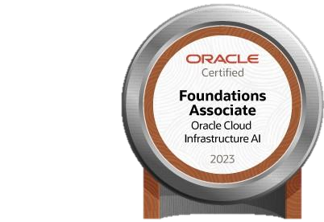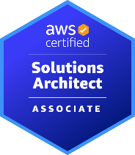

**Ravindra Vemulapalli**

[**ravindravemulapalli14@gmail.com**](mailto:ravindravemulapalli14@gmail.com)

**+1 (469) 427-5134**

[linkedin.com/in/ravindravemulapalli](https://www.linkedin.com/in/ravindravemulapalli)

**Professional Summary**

* 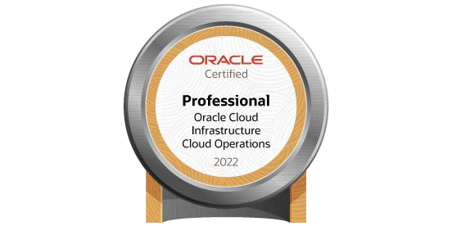I have 15+ years of experience, with 8 years specializing in AWS Cloud and Oracle Cloud Infrastructure (OCI), working as an AWS/OCI Solution Architect for various customers and internal projects. Responsibilities include migrating and managing application infrastructure, as well as Oracle Database Administration.
* Experienced in architecting, designing, implementing, upgrading, and scaling serverless solutions, as well as migrating across multiple platforms into AWS Cloud and OCI. Also exposed to IaaS, PaaS, SaaS, and Infrastructure as Code (IaC).
* Experience of implementing Highly Available and Fault Tolerant architectures across availability zones and regions.
* Assess existing on-premises infrastructure and applications, develop migration strategies, and execute migration plans to AWS/OCI Cloud.
* Working experience with various AWS services, including but not limited to VPC, EC2, S3, RDS, ELB, API Gateway, SQS, SNS, CloudFront, Auto Scaling Groups (ASG), EBS, IAM, Route 53, WAF, GuardDuty, NAT Gateway, IGW, Lambda, EKS, Athena, CloudWatch, CloudTrail, CloudFormation, MGN, CloudEndure, DMS, Trusted Advisor and other services within the AWS family.
* Implemented monitoring, logging, and alerting solutions on AWS/OCI to proactively identify and address performance issues and security threats.
* Implemented application high availability using AWS Elastic Load Balancer (ELB), effectively balancing traffic across instances in multiple availability zones.
* Implemented security best practices and standards to ensure the confidentiality, integrity, and availability of data and applications in the AWS environment.
* Working knowledge of various OCI components such as VCNs, Subnets, Compartments, Compute Nodes, Storage setups, Security Lists (Sec Lists), Network Security Groups (NSGs), Object Storage Service (OSS), Load Balancers (LB), Database as a Service (DBaaS), Internet Gateways (IGWs), NAT Gateways (NGWs), Security Groups (SGs), Dynamic Routing Gateways (DRGs), Fast Connect, Data Safe, Functions, Zero Downtime Migration (ZDM), and other OCI services.
* Experience with relational database technologies including Oracle, MySQL, Cloud OEM-based Managed Database, OCI Autonomous Data Warehouse, and GoldenGate-based replication.
* Experience with Continuous Integration and Continuous Deployment (CI/CD) tools like GitHub and Jenkins.
* Working with Ansible and Terraform for infrastructure automation, Git for version control, and implementing DevOps practices.
* Experience with container-based deployments using Docker, creating Docker images, utilizing Docker Hub, and managing deployments with Kubernetes.
* Having knowledge of Machine Learning concepts.
* Experience within the software development life cycle using Agile and Scrum methodologies.

**Technical Summary**

* Cloud : AWS, OCI
* Devops : Git, GitHub, Jenkins, Puppet, Ansible, Terraform, Docker, Kubernetes
* Databases : Oracle 19c/12c/11g/10g, RDS, MySQL, MongoDB, DynamoDB, Aurora, Redshift
* Operating Systems : Red Hat Linux, Oracle, Ubuntu, Solaris, Windows.
* Languages : PL/SQL, SQL, Shell, Yaml, JSON, Python
* Database Tools : Data pump, Rman, OEM Grid (10g, 11g, 12c, and 13c), and ZDM.
* Network Protocols : TCP, HTTP, HTTPS, UDP.
* Monitoring Tools : Grafana, Dynatrace, EM Grid, Prometheus

**Academic Details**

* + MCA from Andhra University in 2005.

**Certification**

* AWS Certified Solutions Architect – Associate
* Oracle Cloud Infrastructure 2024 Migration Architect Certified Professional
* Oracle Cloud Infrastructure 2023 Multicloud Architect Associate
* Oracle Cloud Infrastructure 2023 AI Foundations Associate
* Oracle Cloud Infrastructure 2021 Architect Associate
* Oracle Cloud Database Migration and Integration 2021 Certified Specialist
* Oracle Cloud Database Services 2021 Specialist
* Oracle Cloud Infrastructure 2022 Cloud Operations Professional

**Project Details Role: AWS Cloud Solution Architect**

**Clients: FedEx Irving TX-USA**

**Company: - Oracle Duration: Dec 2020 to till date**

**Responsibilities:**

* Collaborate closely with customers to understand business requirements and translate them into scalable and cost-effective architectural designs.
* Responsible to drive project completion through entire engagement cycle - pre-sales, design, migration/implementation.
* Conduct architecture reviews, provide recommendations for improvements, and ensure adherence to best practices and security standards.
* Implemented AWS Organizations and Landing Zones using AWS Control Tower, along with AWS IAM for centralized management of AWS accounts, consolidated billing, and access control.
* Migrated servers from on-premises to AWS using VMware, Hyper-V, HCX and the AWS Application Migration Service, AWS Database Migration Service (DMS).
* Experienced in migrating monolithic applications to microservices architecture.
* Implemented real-time monitoring and alerting for applications deployed in AWS, utilizing CloudWatch, CloudTrail, and Simple Notification Service (SNS).
* Supporting hybrid cloud infrastructure by leveraging VPC peering, VPN, Transit Gateway and Direct Connect.
* Wrote Python, terraform, CDK scripts with Cloud Formation templates to automate installation of VPC, EC2, Auto scaling, RDS (Oracle, MySQL, Aurora DB), and other services.
* Configured Amazon RDS Multi-AZ deployments and Oracle Data Guard for high availability.
* Analyzed the source and involved in designing the ETL data load.
* Extensively used ETL to transfer and extract data from source files (Flat files and DynamoDB) and load the data into target database.
* Designed and implemented ETL processes using AWS Glue to extract, transform, and load data from various sources into Amazon Redshift, resulting in a 40% improvement in data processing efficiency.
* Developed custom AWS Glue jobs using Python to handle complex data transformations and enrichments, ensuring data accuracy and consistency.
* Worked closely with development teams to optimize applications for deployment in AWS environments.
* Modernizing applications using serverless architecture on AWS using AWS Lambda, API Gateway, AWS Step Functions, DynamoDB, S3, SQS and Amazon SNS.
* Utilized AWS CDK to provision and manage cloud resources efficiently, resulting in a 30% reduction in infrastructure costs.
* Implemented infrastructure as code (IaC) practices using AWS CDK, automating the deployment of AWS resources and improving deployment reliability.
* Used Jenkins pipelines to drive all micro services builds out to the Docker registry and then deployed to Kubernetes, Created Pods and managed using Kubernetes.
* Utilized AWS Elastic Container Service (ECS) and Elastic Kubernetes Service (EKS) for orchestrating containerized applications, enhancing the deployment process, and ensuring high availability and scalability of services across the Kubernetes cluster.
* Involved in maintaining and editing terraform scripts for application deployment automation.
* Responsible for distributed applications across hybrid AWS and physical data centers.
* Serve as a subject matter expert on AWS/OCI services and architecture, providing guidance and mentorship to junior team members.
* Spearheaded the design and deployment of a robust Disaster Recovery (DR) strategy across multiple regions, utilizing Active/Active and Active/Warm configurations to ensure high availability and resilience.
* Experience with on-call support, resolving incidents and release management practices.
* Followed agile principles and used JIRA for maintenance and Bug development tasks.

**Role: AWS Cloud Architect Client: - Desjardins Group- USA**

**Company: - Oracle Duration: - Feb 2018 to Sep 2019**

**Responsibilities:**

* Responsible for designing, implementing, and supporting cloud-based infrastructure and its solutions.
* Experienced in creating multiple VPCs and public and private subnets as per requirement and distributing them as groups into various availability zones of the VPC.
* Experienced in network equipment like VPC, subnet, route table, Internet Gateway, NAT Gateway, VPC peering, and a Bastion host.
* Used IAM to create roles, users, and groups, Cognito and implemented MFA to provide additional security to the AWS account and its resources.
* Managed policies and permissions for individual AWS accounts, maintaining security and access controls (SCP) across the organization.
* Implemented network firewalls at all layers using security groups, NACL, and AWS Shield, WAF against DDoS attacks and common web exploits.
* Leveraged S3 storage classes to store and managed data. Used Intelligent Tiering and configured S3 life cycle policies to transition and archive objects in S3 Glacier.
* Set up Auto Scaling Groups based on memory and CPU to adapt to unforeseen spikes without having an outage or needing manual intervention.
* Implemented AWS high availability using AWS Elastic Load Balancing (ELB), which performed balance across instances in multiple availability zones.
* Experience with automation and orchestration tools such as AWS CloudFormation and Terraform.
* Building/Maintaining Docker container clusters managed by Kubernetes. Utilized Kubernetes and Docker for the runtime environment of the CI/CD system to build, test deploys.
* Integrated AWS Glue with Amazon S3 for data storage and AWS Lambda for serverless data processing, enabling real-time data analytics capabilities for the organization.
* Successfully led multiple Oracle database migration projects to AWS, ensuring minimal downtime and data integrity.
* Configured Datadog for monitoring and logging of the services to console.
* Automated routine DBA tasks using AWS Lambda and Python.
* Used Ansible Playbooks for Deployment on build on internal Data Centers and re-used and modified same Playbooks to create a Deployment directly into Amazon EC2 instances.
* Set up monitoring and logging using AWS CloudWatch to gain insights into the performance and health of AWS services and applications.
* Worked on creation of custom Docker images, tagging and pushing the images.
* Collaborated with development teams to design and implement AWS CDK constructs for application deployments, reducing time-to-market by 25%.
* Collaborated with cross-functional teams, including development, testing, and operations, to ensure smooth and timely releases.
* Created Confluence pages with project-wise and process-related documents for all the accounts as well as updating them with the latest updates and share with the team.

**Role: Sr. Oracle DBA/Cloud Engineer Client: -Global Clients**

**Company: Oracle India Pvt Ltd, Duration: Dec 2011 to Jan 2018**

**Responsibilities:**

* Experienced in network equipment like VCN, subnet, route table, Internet Gateway, NAT Gateway, VCN peering, and a Bastion host.
* Used Ansible Playbooks for Deployment on build on internal Data Centers and re-used and modified same Playbooks to create a Deployment directly into OCI Compute Instances, Storage Services, DbaaS and Load Balancer.
* Used IAM to create roles, users, and groups, policies and implemented MFA to provide additional security to the OCI account and its resources.
* Working on building Infrastructure and migrating application from data center to cloud.
* Proficient in applying RDBMS patches using OCI cloud console.
* Migrated Oracle Apex from ADC to OCI and integrated with SAML.
* Implemented network firewalls at all layers using security groups, NSG, and WAF against DDoS attacks and common web exploits.
* Developed tools and utilities to automate Database administration tasks using Bash.
* I am responsible for administering, maintaining, and supporting Stage and Production environments in RAC (Real Application Clusters) and ASM (Automatic Storage Management).
* Implemented Ansible to manage all existing servers and automate the build/configuration of new servers.
* Extensively involved in Oracle RAC database installation, upgrades, and patching of business-critical databases.
* Upgraded databases from 11g to 12c.
* Provisioned Compute Instances and Databases with Load Balancer for the required applications.
* Did the In-place upgrade of OS, Grid and Database from 12c to 19c.
* Integrating SSO with OEM 13.5 for monitoring.
* Experience in cloning and refresh activities using RMAN and Manual setup
* Maintaining the Centralized and client-specific Oracle Enterprise Manger 10g/11g/12c/13c).
* Implementation, upgrading, and applying RUs on EM’s based on the client requirements.
* Integrating and configuring the alerts for creating the automated SRs generated from the EM.
* Involved in Exadata DB migration from a standalone database.
* Analyzing all the technical issues/queries and providing timely responses to the customers
* Worked as an individual consultant supporting global client databases.
* Hands-on experience in software and firmware maintenance of both the Database and Storage servers in the Exadata database machine including upgrades and patching.

**Role: Oracle Database Administrator Client-BSNL**

**Company: Ericsson India Pvt Ltd Duration: - May 2008 to Nov 2011**

**Responsibilities:**

* 24*7 production Support for mission critical production systems
* Administering, Monitoring, Maintenance and Patching for the Production instances.
* Configuring backups using various strategies like Cold/Hot/RMAN for all database.
* Monitoring and adding space to the data files as per requirement.
* Creating users, grating roles and privileges to user etc.
* Troubleshooting and fixing the DB issues.