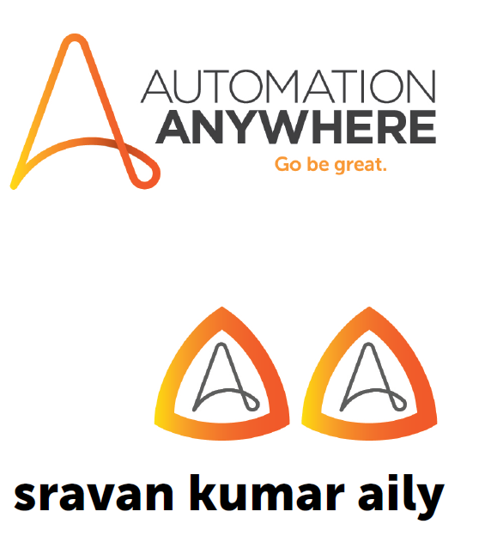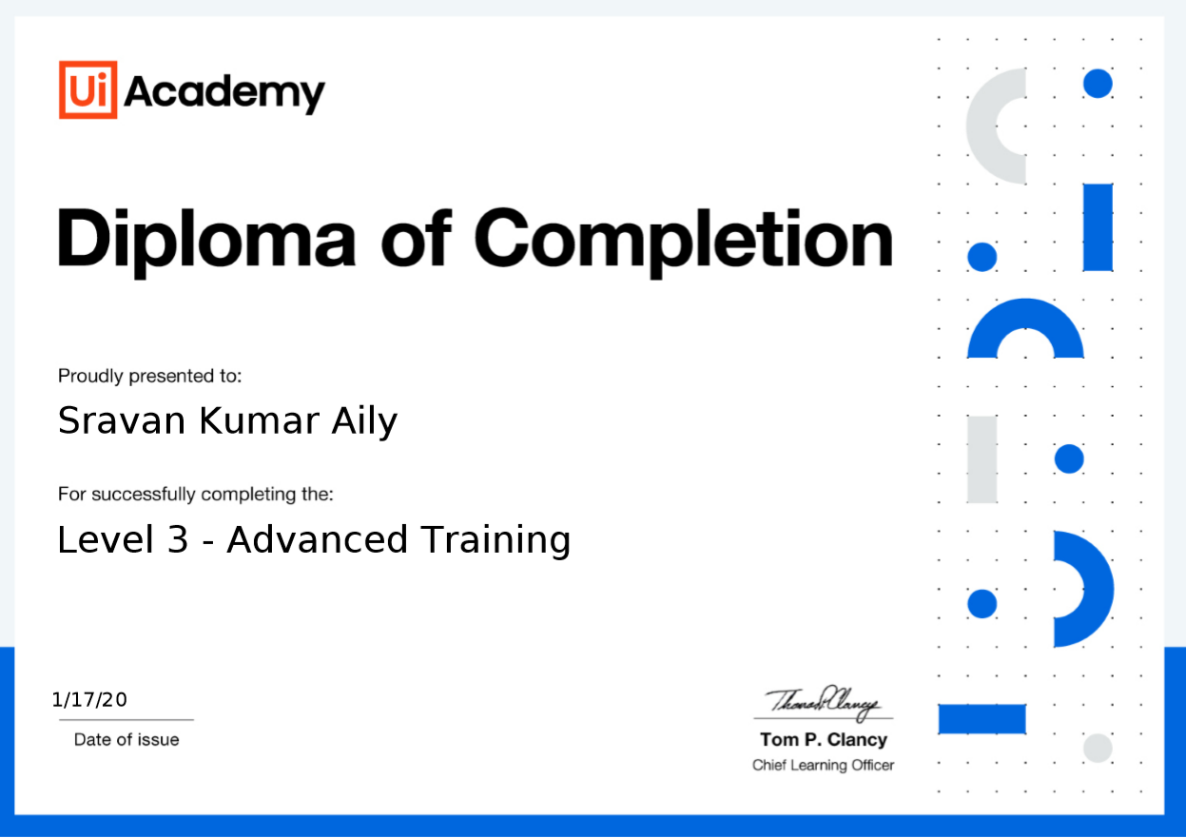

**Sravan Kumar**

**Mobile: (510)-474-8686 Email:aily.sravan@gmail.com**

**PROFESSIONAL SUMMARY**

* Around **10 Years** of experience with 6+ years of RPA experience in end-to-end software development life cycle (SDLC) with strong background in requirements analysis, design, development, testing and performance testing using **Automation Anywhere, UiPath tool** and worked at large customers in Financial, Banking, HealthCare and Mortgage.
* Automated several complex business processes to mimic **human intervention** and provide more **accuracy and added more value to business.**
* Hand on experience in **Robotic Process Automation** (RPA) with Automation Anywhere across different platforms and successful implementation in Production environment.
* Experienced in using UiPath Studio, **Orchestrato**r, Screen, Data & **Web scraping** techniques.
* Creation of Process Definition Document (**PDD**), **TDD** (Technical Design Document) and Solutions Design Document (**SDD**) for Clients to enable and enhance Automation Development.
* Worked closely with customer executive management to implement and provide **RPA** Solutions.
* Experience Development, Testing, and Deployment of bots in UiPath, Automation Anywhere Enterprise platform.
* Good Experience in developing and **Automating Web Applications**, **SAP, Excel Automations** and preparing bots in UiPath.
* Hands on experience with UiPath stages, Flowcharts, sequences, block user input and getting source element.
* Evaluated tools and performed feasibility checks to help select suitable Automation tools for **RPA implementation**.
* Exception handling design and correct use of stages and blocks correct use of data types, Session and Environment variables.
* Enhanced control over activity updates on robots in UiPath studio.
* Expert in automating the data in Excel sheets using Automation Anywhere.
* Expertise in preparing and presenting **business cases** for automatable processes, solution designing, and developing automation tasks for the **identified processes**.
* Experience in structured, Table and pattern-based data extraction in using Web Data Extraction and export the data to CSV.
* Worked very close with Subject Matter Experts (SMEs) to translate process in detailed design documents and educated SME’s to work with **Bots** in production.
* Automated numerous routine tasks using Automation Anywhere, thereby reducing manual intervention.
* Experience in writing SQL queries, PL-SQL programming for packages, stored procedures etc., using Oracle.
* Programming background in VB, HTML, XML, CSS and JavaScript.
* Expertise in Root Cause Analysis for production bugs and troubleshooting in critical real time scenarios.
* Experience in Waterfall and Agile/Scrum methodology of software development.
* Proven track record in accomplishing the project deliverables within the time frame.
* Excellent interpersonal and customer relational Skills. Proven communication, presentation Skills and Leadership Qualities.

**TECHNICAL SKILLS**

|  |  |
| --- | --- |
| **Operating Systems** | Windows XP/7, Linux. |
| **Languages** | JAVA, SQL, and VBA Macro |
| **Database Technologies** | Oracle, MS Access. |
| **Java Web Technologies** | JDBC, JSP, Web Services, VBA,  REST, Spring 2.5/3.x, Hibernate 2.5/3.x |
| **Web Technologies** | HTML, Java Script, XML |
| **IDE Tools** | Eclipse 3.0 |
| **Automation Tools** | Automation Anywhere, AA 360, UiPath |

**EDUCATION:**

* Bachelor of Technology in Computer Science from JNT University Hyderabad, India, 2010.
* Masters in computer science from Northwestern Polytechnic University, California, USA 2016.

**CERTIFICATION:**

* RPA Developer Certified in (Advance Professional Automation Anywhere Tool)
* RPA Developer Certified in UiPath Advanced Professional (UiARD)

**WORK EXPERIENCE**

**State of Maryland (DHS), Remote, MD Jan 2022 – Till Date**

**Sr Automation Engineer**

**Responsibilities:**

* Development, configuration, and operations of automation processes per technical design documentation.
* Development, configuration, and operations of automation processes per technical design documentation.
* Full understanding of functional requirements and ensuring they are fully addressed in technical solution.
* Troubleshoot problems with RPA processes, providing timely responses and solutions as required. Create and maintain formal technical design documents.
* Create bots in Automation Anywhere application to eliminate redundant manual activities.
* Build effective Robotic Process Automation that interacts with various web/desktop-based tools and applications.
* Understand existing processes and facilitate change requirements as part of a structured change control process.
* Created and documented test procedures and scenarios for the pre-UAT phases and to support the operational teams during the UAT, rollout phases and debugging root causes of any issues.
* Worked closely with the business to create SDD, TDD and test strategy document.
* Provided Exception handling at each & every possible scenario for a robust error-free development.
* Solve day to day issues arising while running robotic processes and provide timely resolutions.
* Provide solution to fix the identified manual process automation and review the optimized and automated process.
* Monitor production environment after implementations and resolve application/technical problems of the highest complexity.

**Technologies:**Ui Path, HTML, CSS, JavaScript, Java, MS SQL Server, VB Script, VBA Macro, Visio, Azure, GIT, MS Access.

**Accelirate, Columbia, MD Dec 2019 – Jan 2022**

Worked with multiple clients **(AmeriGas, Facebook, Berry Appleman & Leiden)**

**Sr RPA Developer**

**Responsibilities:**

* Responsible for implementing the full lifecycle of RPA solutions identifying automation opportunities, gather requirements, implement, test, and deploy targeted automation solutions using industry leading RPA tool UiPath.
* Hands on experience in building and developing different types of Applications (Browser, SAP, Excel Automation payroll system) by using UiPath.
* Developing new Processes and Objects using core workflow principles that are efficient, well structured, maintainable and easy to understand.
* Used Data Scraping method for extracting structured data from browser applications or documents into a CSV file or Excel Spreadsheet.
* Interacted with different mail services such as POP3, OUTLOOK and IMAP to get the mail messages into folder.
* Used UiPath automation elements such as Mouse, Keyboard and Attribute to automate the desktop sequence activities.
* Participate in online meetings to demonstrate the capabilities of RPA for on-going projects and potential clients.
* Developed REFramework in UiPath for exception handling & used to define states in project.
* Developed the scripts using different UI elements and created Batch files to execute the Bots without any manual intervention.
* Used image activities with wait conditions to ensure proper website or application loading, to perform certain actions in a loop.
* Created and documented test procedures and scenarios for the pre-UAT phases and to support the operational teams during the UAT, rollout phases and debugging root causes of any issues.
* Used Excel automation for repetitive Excel data entry, appending and for comparing columns.
* Interacted with the different send services of mail to send automatic mails and audit logs regarding the task completion.
* Handled exceptions using Try-Catch activity.
* Handled the Execution of project in UiPath Robot and Deployed the process in UiPath Orchestrator and scheduled their execution.
* Used Queues to collect information from orchestrator to perform additional tasks.
* Worked closely with the business to create SDD, TDD and test strategy document.
* Created and adapted system variables for the environment to use within the automations to be able to function in UAT and production.
* Participated in peer-to-peer review to deliver high quality digital automation with reusable components and consistent with best practice methodology.
* Extensively worked on debugging applications for fixing bugs and Production support.
* Identify and communicate the technical infrastructure requirements to design RPA process solutions in accordance with standard RPA design principles and conventions.

**Technologies:**UiPath, HTML, CSS, JavaScript, Java, MS SQL Server, VB Script, Visio, Azure, MS Access.

**ICMA-RC, Richmond, VA Jun 2019 – Dec 2019**

**RPA Developer**

**Responsibilities:**

* Responsible for implementing the full lifecycle of RPA solutions identifying automation opportunities, gather requirements, implement, test, and deploy targeted automation solutions using industry leading RPA tool Automation Anywhere.
* Created reusable automation framework with MetaBots and reusable libraries with data externalization for RPA implementation.
* Experience in configuring and automating the Outlook mail activities using VBA Macros.
* Developed demos based on the automation performed and show cases the same to potential internal/external customers.
* Good understanding and experience using Microsoft Office, including the ability to read Excel macros to translate them to RPA solutions and/or integrations.
* Participate in online meetings to demonstrate the capabilities of RPA for on-going projects and potential clients.
* Worked on Automation Anywhere Control Room V11 that enables you to deploy, schedule, monitor and manage Robots and processes, while business exception handling is available through centralized work queues.
* Worked on using Excel and CSV commands with Automation Anywhere and experienced in using send Email command to Email reports and errors.
* Created and documented test procedures and scenarios for the pre-UAT phases and to support the operational teams during the UAT, rollout phases and debugging root causes of any issues.
* Worked closely with the business to create SDD, TDD and test strategy document.
* Provided Exception handling at each & every possible scenario for a robust error-free development.
* Created and adapted system variables for the environment to use within the automations to be able to function in UAT and production.
* Participated in peer-to-peer review to deliver high quality digital automation with reusable components and consistent with best practice methodology.
* Administered managing the robot's workloads using Automation Anywhere Work Queues and to identifying and debugging the errors using Error Handlers.
* Extensively worked on debugging applications for fixing bugs and Production support.
* Identify and communicate the technical infrastructure requirements to design RPA process solutions in accordance with standard RPA design principles and conventions.
* Worked on testing, experimented with and used various metabots along with provided suggested changes to the metabot designers within the AAPeople Automation Anywhere portal.
* Experience with MGage API, within the REST call commands along with variables to process SMS text messages as notifications to contacts listed with automations.
* Established CyberArk Credential Valut and used xml configuration files to populate CyberArk metabot utility parameters in order to access and process SQL queries and secure functions.

**Technologies:**Automation Anywhere 11.3.1,VBA, HTML, CSS, JavaScript, Java, Chrome driver, MS SQL Server, HTML, CSS, VB Script, MS Access.

**USAA Bank, San Antonio, TX Feb 2017 – Jun 2019**

**RPA Developer**

**Responsibilities:**

* Designing and documenting automated process solutions in accordance with standard design principles and conventions.
* Configuring new automations and objects using core workflow principles that are efficient, well structured, maintainable and easy to understand.
* Implemented new reporting techniques and facilitated the presentations to the clients.
* Innovatively integrated the advanced features of automation tools like OCR, Web Recorder for existing robots and improved the performance.
* Maintain and the several RPA bots as batch processes on daily basis and ensure quality and high performance to the internal and vendor applications of the organization.
* Problem solving issues that arise in day to day running of robotic processes and providing timely responses and solutions as required.
* Formulated and executed Agile processes for enhancing performance.
* Experience in staging and deploying the automation solution into test and live environments.
* Enhance the bots with additional features as requested by the clients and business analysts.
* Experience in programming for generating graphs, data listings and tables using data steps, procedures, SQL and macros.
* Investigated existing SAS code, created query, maintained and defined strategies to improve the efficacy of SAS programs.
* Generated automated exception reports using advanced EMAIL automation.
* Implemented changes in coding and designs using knowledge of VBA.
* Proactively designed RPA Tasks as per application and business requirements.
* Created HTML navigation menu that is rolebased menu items changes dynamically, derived from the database in the form of XML.
* Developed and implemented new technical solutions for production applications to interact effectively with users.
* Pair Programming with the Development team to capture the failing scenarios inorder to avoid defects in future and ensure functionality.

**Technologies:**Automation Anywhere, SAS, VBA, HTML, CSS, JavaScript, Java, J2EE,Chrome driver, MS SQL Server, DB Visualiser, VB Script, MS Access.

**2x12 Software Solutions Pvt Ltd Aug 2011 – Oct 2014**

**Associate Software Engineer**

**Responsibilities:**

* Involved in design, development and deployment of Global Support Services Portal project.
* Developed UI pages using Struts 2 MVC, HTML5, CSS, JavaScript, JSTL and JSP.
* Developed modules like Metrics, SubCases, GSS News, Certifications and VFI Modules using Struts 2 MVC and Spring Framework.
* Involved in Integrating Documentum Enterprise Content Management application through GSS Portal.
* Involved in phased rollout of Portal for Global Regions and training sessions for seamless transfer of portal knowledge to Client Teams.
* Modified existing database structures to support additional features using SQL queries.
* Developed test cases and performed unit testing using JUNIT and Interacted closely with the QA team to understand and fix issues.
* Actively involved in solving the production defects on priority bases and provided the postproduction support and actively responded to L2 calls and emails.
* Involved in solving production defects on priority bases and provided the postproduction support and actively responded to L2 calls and emails.
* Worked closely with onsite teams to migrate, deploy and test multiple releases.
* Developed and maintained a repository of detailed documentation on various fixes, enhancements and lessons learnt.

**Technologies:**JDK 1.6, Spring 3.0, Hibernate 3,Struts 2.1,SOAPServices, Documentum 6,XML, Oracle 10g, Linux, Maven, JBoss 6, SubVersion and Eclipse.