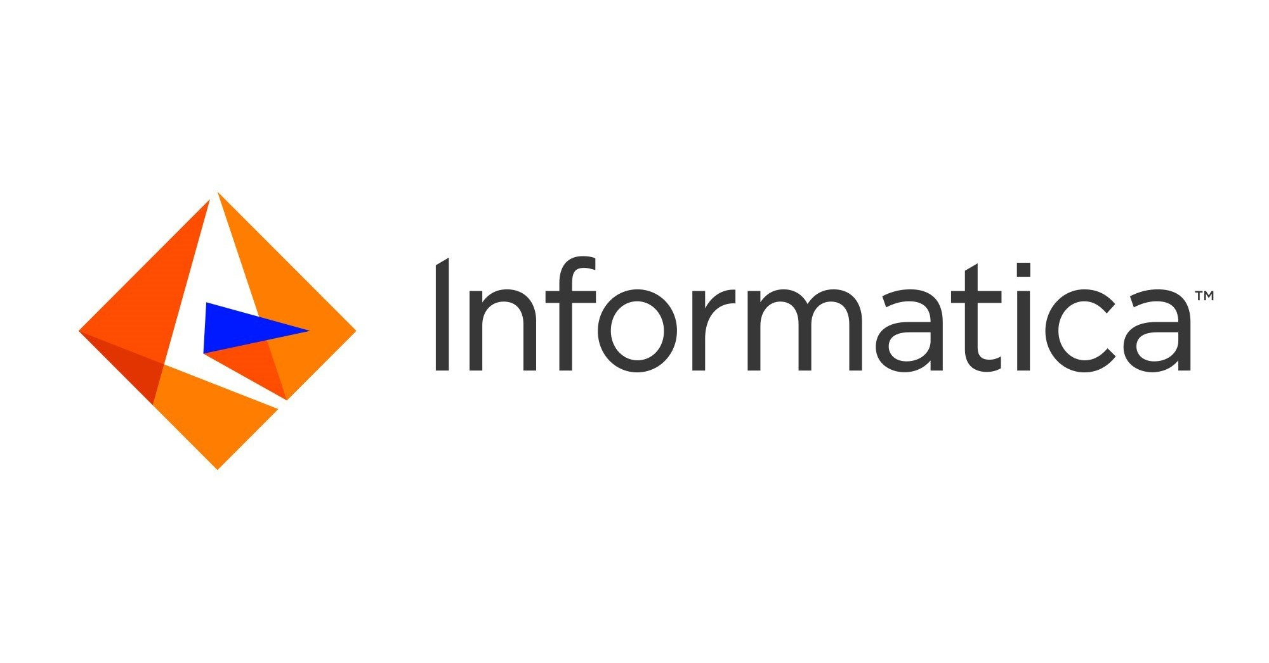
SreeHarsha Devoji
desree986@gmail.com
510-585-3339
Profile Summary:

8+ years of Experience in SDLC including architecture, analysis, design, development, testing, implementation & maintenance of applications in Informatica, Oracle, SQL Server, DB2 and UNIX.
- Experience in various stages of System Development Life Cycle (SDLC) and its approaches like Waterfall, Agile Model.
- Experience in development and design of ETL (Extract, Transform and Loading data) methodology for supporting data transformations and processing, in a corporate wide ETL Solution using Informatica PowerCenter9.6.1/9.5.1/9.1/8.6/7.1
- Experience in OLTP Modeling (2NF,3NF) and OLAP Dimensional modeling (Star and Snow Flake)
- Created Mappings in Mapping Designer to load data from various sources using complex transformations like transaction control, Lookup (Connected and Un-connected), Joiner, sorter, Aggregator, Update Strategy, Filter and Router transformation.
- Experienced in Oracle database development using PL/SQL, Stored Procedures, Functions and Packages.
- Extensive experience in Creating and maintaining Database Objects like Tables, Views, Materialized views, Partitions, Indexes, Constraints, Primary keys, Sequence, Synonyms and Database Links.
- Experience in SQL*Loader Utility, External tables and UTL FILE Collections, Records and Dynamic SQL.
- Experience working with SQL Server, DB2, SSIS packages, UNIX and Business objects reporting tool.
- Good hands-on Source Code Management (Version Control System) tools like Git and Subversion to maintain Informatica code.
- Experienced In working with various Scheduling tools like Autosys, Informatica Scheduler and Appworx.
- Experience working with clients on-site and with offshore teams while analyzing software requirements and developing solutions.
- Worked as a part of team in 24x7 production environment and provided on-call and day-to-day support.
- Possess good communication, quality center skills, quick learning ability and to lead and train the team both functionally and technically.

Education Details:
Bachelors in Electronics Engineering Jawaharlal Nehru Technological University Hyderabad 2012
Masters in MSIT, SHU 2016

Technical Skills:

Operating Systems | Windows 2000, Windows NT, Windows XP, UNIX. Windows NT 4.0/2000/XP/98/95, UNIX, OS/390.
Databases | Oracle 8i/9i/10g/11g, Db2, Teradata, SQL Server, MS-Access
Languages | C, C++, Java, UNIX Shell Scripts, SQL, Transact-SQL, PL/SQL, COBOL, and Visual Basic 6.0/. Net, XML
Tools | TOAD, PL/SQL Developer, Informatica10.x/9.x/8.x/7.x/6.xPowerCenter / Developer, WorkFlow Manager, Workflow Monitor, Designer, Server Manager, Repository Manager, MDM Informatica.
Project Summary
Client: Comerica Bank (ETL Developer) Dec2021-Current Location: Dallas, TX
Sr. ETL Informatica Developer
Is an American financial services company founded in Detroit, Michigan. It is the 22nd largest U.S. financial holding company, with $69.3 billion in total assets, $48.2 billion in total loans, and $57 billion in total deposits as of March 31, 2015. It is the largest U.S. commercial bank headquartered in Texas. The company's operating units include the Business Bank, the Retail Bank, and Wealth Management.
Responsibilities:
- Used transformations such as the source qualifier, aggregators, connected & unconnected lookups, filters, sorter, stored procedures, router & sequence generator.
- Developed Reusable Mapplets and Transformations for standard business calculations.
- Extensively used various Performance tuning Techniques to improve the session performance.
- Improved workflow performance by shifting filters as close as possible to the source and selecting tables with fewer rows as the master during joins.
- Created events, decision and tasks in the work flows using workflow manager.
- Implemented performance tuning by using lookup caches, using tables with fewer rows as the master table in joiner transformations, dropped indexes and re-created them after loading data to targets and increased the commit interval.
- Executed sessions, sequential and concurrent batches for proper execution of mappings.
- Executed Pre and Post session commands on Source and Target database using Shell Scripting.
- Scheduled Sessions to update the target data using workflow Manager of Informatica and Involved in test case preparation.
Environment:
Informatica Power Center 9.6, informatica Developer (IDQ) Informatica, Power Exchange 10.x, Oracle 11i/10g, DB2, Mainframes, SQL Server, TOAD, SFDC, SQL, Windows XP, UNIX.

Client: Red Ventures July 2019-Dec 2021
Location: Austin, TX
Sr. ETL Informatica Developer
Responsibilities:
- Gathering requirements from the business users.
- Involved in creating Impact Analysis, Technical Design Document and Test cases.
- Using Informatica PowerCenter Designer analyzed the source data to Extract & Transform from various source systems (oracle 10g, DB2, SQL server and flat files) by incorporating business rules using different objects and functions that the tool supports.
- Using Informatica PowerCenter created mappings and mapplets to transform the data according to the business rules.
- Used various transformations like Source Qualifier, Joiner, Lookup, SQL, and router, Filter, Expression and Update Strategy.
- Developed mapping parameters and variables to support SQL override.
- Created mapplets to use them in different mappings.
- Tuned the Informatica mappings for optimal load performance.
- Developed PL/SQL Packages, Procedures, Functions as per the requirement.
- Involved in creating and maintaining Indexes, GTT and Partition Tables.
- Used Collections, Records and Ref cursors to process bulk loads to improve performance.
- Designed SSIS packages Using Control Flow Tasks like for Loop Container, For Each Loop Container, Sequential Container, Execute SQL Task, Execute Package Task, Script Task, Send Mail Task and Data Flow Task.
- Involved in Peer reviews and guided the team for better solutions.
- Performed Unit, Integration Testing and UAT Testing.
- Worked on control-m for batch scheduler.
- Developed UNIX shell scripts to customize the server scheduling jobs and used Autosys to schedule the jobs.
- Worked as a part of a team and provided 24 x 7 support when required.

Environment:
Informatica 9.6/8.6, Oracle 11g/10g, Toad, SQL Server 2008 and SSIS Packages, UNIX AIX, Autosys, Quality Center, GIT.

Client: Corporate systems/RingCentral July 2018–June 2019
Location: Belmont, CA
Sr. ETL Informatica Developer
Responsibilities:
- Gathering requirements from the business users.
- Analyzing the applications.
- Creating the technical specifications.
- Developed PL/SQL Packages, Procedures, Functions, Triggers, Views, Indexes, Sequences and Synonyms.
- Developed ETL processes to load data from different source systems such as Oracle, XML, SQL Server 2008, and Flat Files into target systems i.e. Oracle
- Developed mappings in Informatica to load the data from various sources into the Data Warehouse, using different transformations like Joiner, Aggregator, Update Strategy, Rank, Router, Lookup, Sequence Generator, Filter, Sorter, Source Qualifier.
- Worked with various look up cache like Dynamic Cache, Static Cache, Persistent Cache, Re Cache from database and Shared Cache.
- Used Informatica’s features to implement Type 2, 3 changes in slowly changing dimension tables.
- Designed and developed mappings using Source Qualifier, Expression, Lookup, Router, Aggregator, Filter, Sequence Generator, Stored Procedure, control-m Update Strategy, joiner and Rank transformations.
- Managed the Metadata associated with the ETL processes used to populate the Data Warehouse.
- Implemented complex business rules in Informatica Power Center by creating Re-usable transformations, and Robust Mapplets.
- Worked on Teradata and its utilities - tpump, fastload through Informatica. Also created complex Teradata Macros.
- Implemented performance tuning of Sources, Targets, Mappings and Sessions by identifying bottlenecks and used Debugger to debug the complex mappings and fix them.
- Performed Unit, Integration Testing and validated results with end users.
- Worked as a part of a team and provided 24 x 7 support when required.

Environment:
Oracle 9i/10g, ORACLE SQL Developer, Informatica 9.0/8.6, SQL Server 2005/2008, DIS Scheduler, Autosys, Microsoft Visio.

Client: infinity solutions/ Hertz June2017 – June 2018
Location: Oklahoma City, Oklahoma
Role: ETL Informatica Developer.
Responsibilities:

- Involved in complete software development life cycle.
- Gathered the business requirements by interacting with users.
- Creating High Level Design Documents.
- Creating Technical Specifications and Test cases in Quality Center.
- Developed PL/SQL Packages, Procedures, Views, Sequences and Triggers in different schemas to integrate with other applications.
- Involved in performance tuning of queries using Indexing, Partitioning.
- Used Bulk Binding, Collections, Records, Ref Cursors and Temporary tables to handle bulk loads.
- Created Materialized views for the reports.
- Developed mappings in Informatica to load the data including facts and dimensions from various sources into the Data Warehouse, using different transformations like Source Qualifier, JAVA, Expression, Lookup, Aggregate, Update Strategy and Joiner.
- Developed reusable Mapplets and Transformations.
- Optimized the performance of the mappings by various tests on sources, targets and transformations
- Design, develop and Informatica mappings and workflows; Identify and Remove Bottlenecks in order to improve the performance of mappings and workflows
- Review existing code, lead efforts to tweak and tune the performance of existing Informatica processes
- Scheduling the sessions to extract, transform and load data into warehouse database on Business requirements.
- Scheduled the tasks using Autosys.
- Loaded the flat files data using Informatica to the staging area.
- Developed Complex mappings in Informatica to load the data from various sources using different transformations.
- Responsible for providing support and plans to offshore team.
- Involved in Unit Testing and Integration Testing.
- Involved in code reviews.
- Coordinated with different teams while doing production support and analysis.
- Worked as a part of a team and provided 24 X 7and on-call supports whenever required.

Environment: Oracle 10g, Informatica Power center 8.6, Oracle SQL developer, Toad, F-Secure Client, Sun Solaris, UNIX shell scripts, Autosys, Microsoft Visio.

Client: United Health care Feb 2015– May 2017
Location: Minneapolis, MN
ETL Informatica Developer
Responsibilities:

- Analyzed the requirements and framed the business logic for the ETL process.
- Extracted data from Oracle as one of the source databases.
- Involved in JAD sessions for the requirements gathering and understanding.
- Involved in the ETL design and its documentation.
- Interpreted logical and physical data models for business users to determine common data definitions and establish referential integrity of the system using ER-STUDIO.
- Followed Star Schema to design dimension and fact tables.
- Experienced in handling slowly changing dimensions.
- Collect and link metadata from Diverse sources, including relational databases Oracle, XML and flat files.
- Responsible for the development, Implementation and support of the databases.
- Extensive experience with PL/SQL in designing, developing functions, procedures, triggers and packages.
- Developed mappings in Informatica to load the data including facts and dimensions from various sources into the Data Warehouse, using different transformations like Source Qualifier, JAVA, Expression, Lookup, Aggregate, Update Strategy and Joiner.
- Developed reusable Mapplets and Transformations.
- Used data integrator tool to support batch and for real time integration and worked on staging and integration layer.
- Optimized the performance of the mappings by various tests on sources, targets and transformations
- Design, develop and Informatica mappings and workflows; Identify and Remove Bottlenecks in order to improve the performance of mappings and workflows
- Review existing code, lead efforts to tweak and tune the performance of existing Informatica processes
- Scheduling the sessions to extract, transform and load data into warehouse database on Business requirements.
- Scheduled the tasks using Autosys.
- Loaded the flat files data using Informatica to the staging area.
- Created SHELL SCRIPTS for generic use.
- Created high level design documents, technical specifications, coding, unit testing and resolved the defects using Quality Center 10.
- Developed unit/assembly test cases and UNIX shell scripts to run along with daily/weekly/monthly batches to reduce or eliminate manual testing effort.

Environment:Windows XP/NT, Informatica PowerCenter 9.1/8.6, UNIX, Teradata V-14, Oracle 11g, Oracle Data Integrator, SQL, PL/SQL, SQL Developer, ER-win, Oracle Designer, MS VISIO, Autosys, Korn Shell, Quality Center 10.

Client: Synopsys July2012 – July 2014
Location: Hyderabad, India
ETL Developer
Responsibilities:

- Involved in gathering the requirements and system specifications from users.
- Created the Functional specifications, Technical specifications and Use Cases.
- Developed PL/SQL Packages, Procedures, Functions, Triggers, Views, Indexes, Sequences and Synonyms.
- Created a new forms and Modified the existing forms and Pro*C programs according to the business logic.
- Designed and developed Informatica ETL mappings to extract master and transactional data from heterogeneous data feeds and load
- Installed and Configured the Informatica Client tools.
- Worked on loading of data from several flat files to XML Targets.
- Designed the procedures for getting the data from all systems to Data Warehousing system.
- Created the environment for Staging area, loading the Staging area with data from multiple sources.
- Analyzed business process workflows and assisted in the development of ETL procedures for moving data from source to target systems.
- Used workflow manager for session management, database connection management and scheduling of jobs.
- Involved in Unit testing, Integration, UAT testing.
- Interacted with end user for problems faced and providing necessary technical support by fixing the bugs.
- Involved in DBA activities like creating a USER, providing roles, privileges, Grants, Revokes and Locking the User accounts.
- Guided team in writing the efficient code for different interfaces.
- Coordinate with different teams while doing production support
- Worked as a part of a team and provided 24 X 7 support and on-call when required.

Environment: Oracle 10g, PL/SQL, Db2, TOAD 9.5, SQLPLUS, SQL*LOADER, Informatica Power Center 7.1/8.6, UNIX AIX 5.1, Telnet

